**PyCitySchools Analysis**

**## Trends**

1.There appears to be a significant trend toward lower over-all passing rates once the total number of students surpasses 2283 regardless of the fact that the budget per student is larger.

2. The second trend is that the Charter Schools all have significantly across the board higher math and reading scores and higher over-all passing rates with smaller budgets per student.

**I did not get to the following sections:**

* Scores by School Spending
* Scores by School Size
* Scores by School Type

### **NOTE**: ### This code using the lambda to compute the % Passing Math and % Reading does work BUT it *is NOT my creation*. I had help with this part. I had used the code from my District summary but my method returned percentages that were incorrect:

School_Sum["% Passing Math"] = round((SchSum_df.apply(**lambda** x: (x["Math Score"] >= 70).sum()) /

School_Sum["Total Students"]) * 100, 2)

School_Sum["% Passing Reading"] = round((SchSum_df.apply(**lambda** x: (x["Reading Score"] >= 70).sum()) /

School_Sum["Total Students"]) * 100, 2)

School_Sum["Overall Passing Rate"] = round((School_Sum["% Passing Math"] +

School_Sum["% Passing Reading"]) / 2, 2)

**District Summary**



**School Summary**

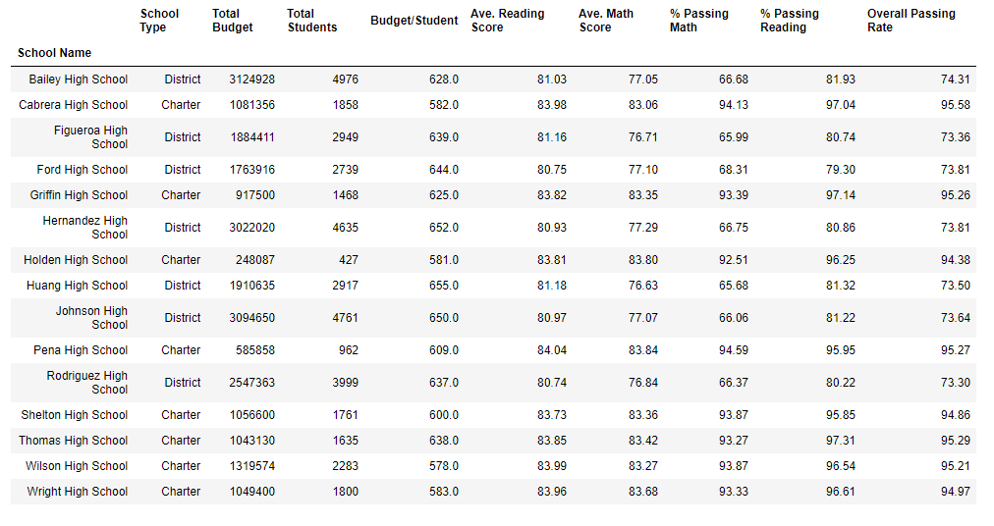

**Top Performing Schools**

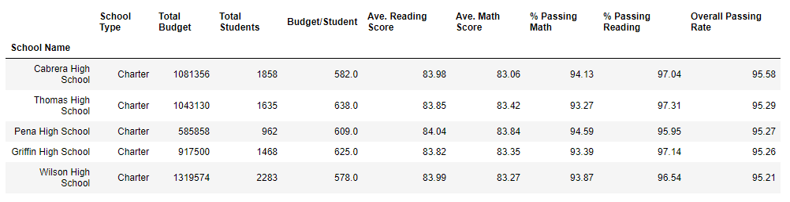

**Bottom Performing Schools**

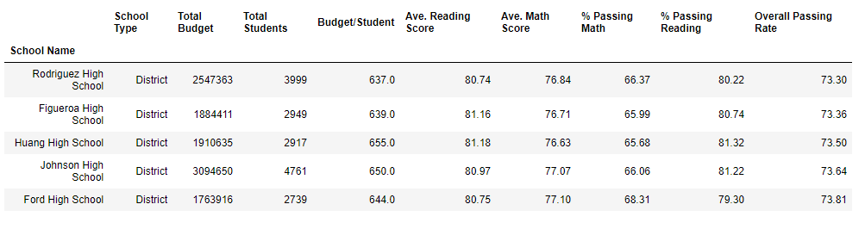

**Reading and Math Scores by School and Grade**

|  |  |  |  |
| --- | --- | --- | --- |
| School Name | Grade | Reading Score | Math Score |
|  |  | mean | mean |
| Bailey High School | 10th | 80.907183 | 76.996772 |
| Bailey High School | 11th | 80.945643 | 77.515588 |
| Bailey High School | 12th | 80.912451 | 76.492218 |
| Bailey High School | 9th | 81.303155 | 77.083676 |
| Cabrera High School | 10th | 84.253219 | 83.154506 |
| Cabrera High School | 11th | 83.788382 | 82.76556 |
| Cabrera High School | 12th | 84.287958 | 83.277487 |
| Cabrera High School | 9th | 83.676136 | 83.094697 |
| Figueroa High School | 10th | 81.408912 | 76.539974 |
| Figueroa High School | 11th | 80.640339 | 76.884344 |
| Figueroa High School | 12th | 81.384863 | 77.151369 |
| Figueroa High School | 9th | 81.198598 | 76.403037 |
| Ford High School | 10th | 81.262712 | 77.672316 |
| Ford High School | 11th | 80.403642 | 76.918058 |
| Ford High School | 12th | 80.662338 | 76.179963 |
| Ford High School | 9th | 80.632653 | 77.361345 |
| Griffin High School | 10th | 83.706897 | 84.229064 |
| Griffin High School | 11th | 84.288089 | 83.842105 |
| Griffin High School | 12th | 84.013699 | 83.356164 |
| Griffin High School | 9th | 83.369193 | 82.04401 |
| Hernandez High School | 10th | 80.660147 | 77.337408 |
| Hernandez High School | 11th | 81.39614 | 77.136029 |
| Hernandez High School | 12th | 80.857143 | 77.186567 |
| Hernandez High School | 9th | 80.86686 | 77.438495 |
| Holden High School | 10th | 83.324561 | 83.429825 |
| Holden High School | 11th | 83.815534 | 85 |
| Holden High School | 12th | 84.698795 | 82.855422 |
| Holden High School | 9th | 83.677165 | 83.787402 |
| Huang High School | 10th | 81.512386 | 75.908735 |
| Huang High School | 11th | 81.417476 | 76.446602 |
| Huang High School | 12th | 80.305983 | 77.225641 |
| Huang High School | 9th | 81.290284 | 77.027251 |
| Johnson High School | 10th | 80.773431 | 76.691117 |
| Johnson High School | 11th | 80.616027 | 77.491653 |
| Johnson High School | 12th | 81.227564 | 76.863248 |
| Johnson High School | 9th | 81.260714 | 77.187857 |
| Pena High School | 10th | 83.612 | 83.372 |
| Pena High School | 11th | 84.335938 | 84.328125 |
| Pena High School | 12th | 84.59116 | 84.121547 |
| Pena High School | 9th | 83.807273 | 83.625455 |
| Rodriguez High School | 10th | 80.629808 | 76.6125 |
| Rodriguez High School | 11th | 80.864811 | 76.395626 |
| Rodriguez High School | 12th | 80.376426 | 77.690748 |
| Rodriguez High School | 9th | 80.993127 | 76.859966 |
| Shelton High School | 10th | 83.441964 | 82.917411 |
| Shelton High School | 11th | 84.373786 | 83.383495 |
| Shelton High School | 12th | 82.781671 | 83.778976 |
| Shelton High School | 9th | 84.122642 | 83.420755 |
| Thomas High School | 10th | 84.254157 | 83.087886 |
| Thomas High School | 11th | 83.585542 | 83.498795 |
| Thomas High School | 12th | 83.831361 | 83.497041 |
| Thomas High School | 9th | 83.72885 | 83.590022 |
| Wilson High School | 10th | 84.021452 | 83.724422 |
| Wilson High School | 11th | 83.764608 | 83.195326 |
| Wilson High School | 12th | 84.317673 | 83.035794 |
| Wilson High School | 9th | 83.939778 | 83.085578 |
| Wright High School | 10th | 83.812757 | 84.010288 |
| Wright High School | 11th | 84.156322 | 83.836782 |
| Wright High School | 12th | 84.073171 | 83.644986 |
| Wright High School | 9th | 83.833333 | 83.264706 |